18CSC305J– Artificial Intelligence

CT2- Answer Key Set-B-Batch-2

- a). Find the heuristic path for the following graph using the various informed search algorithms. Goal node “X” (15)
A
P
Q
R
S
T
U
V
W
X
5
2
4
1
3
1
5
2
3
Node | H(n)
P | 12
Q | 4
R | 7
S | 3
T | 8
U | 2
V | 4
W | 9
X | 0
A | 13

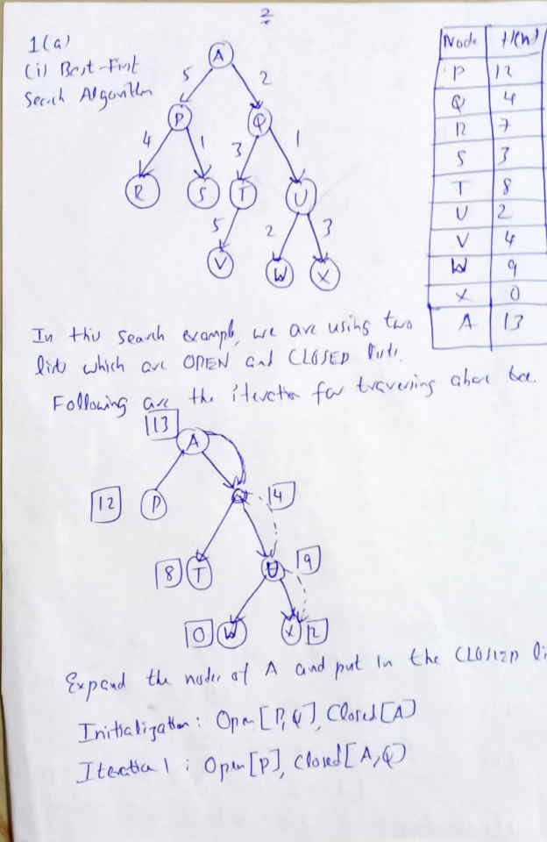

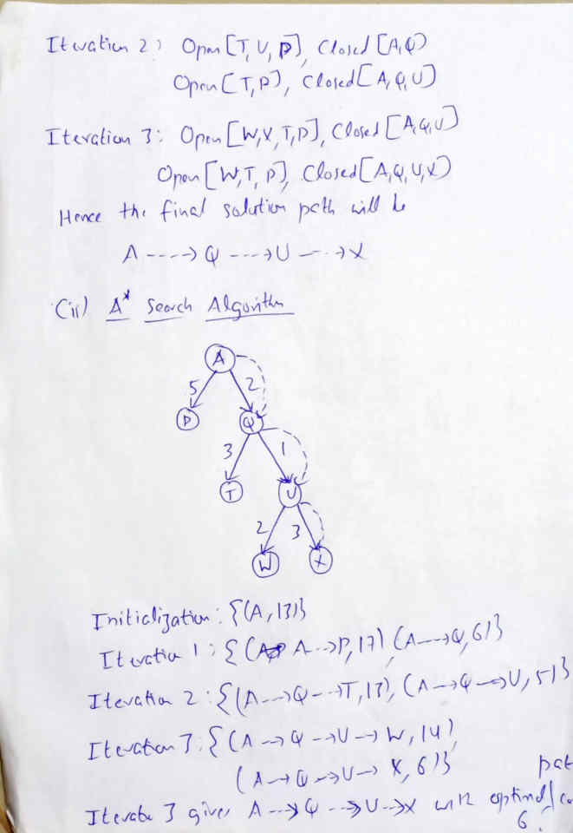

- Find the path to reach the node ‘G’ from the starting node ‘S’ using the BFS and DFS (10)
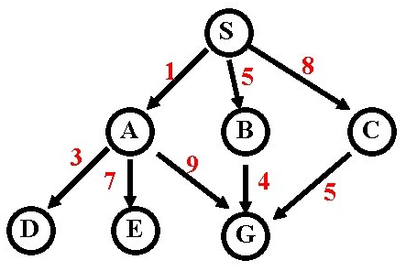

DFS: S→ A→D→E→G
BFS : S→A→B→C→D→E→G

- Demonstrate the two-player search tree to understand the working of Alpha-beta pruning.
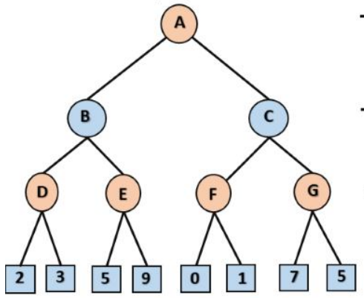

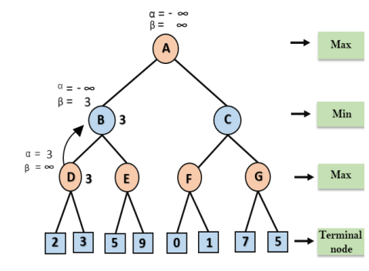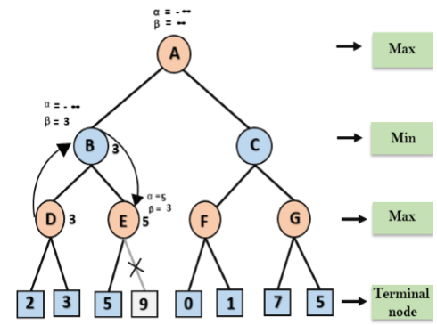

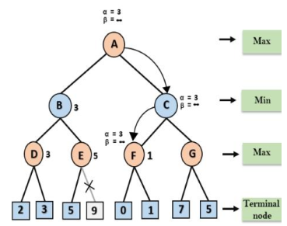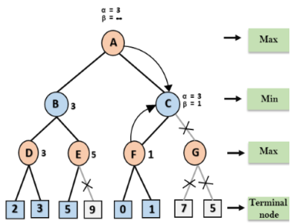

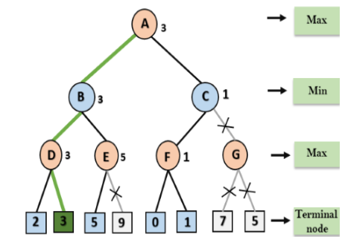

- Mention the key difference between min-max and alpha beta pruning

Both algorithms should give the same answer. However, their main difference is that alpha-beta does not explore all paths, like minimax does, but prunes those that are guaranteed not to be an optimal state for the current player, that is max or min. So, alpha-beta is a better implementation of minimax.
Here are the time complexities of both algorithms
- Minimax: O(b^{d})
- Alpha-beta (best-case scenario): O(b ^{d /2})=O(√b^{d})
- where b is an average branching factor with a search depth of d plies.

- List and explain the problematic regions which makes not to reach the best possible solutions.
Assume you were asked to place 8 queens on an 8x8 chessboard such that no two queens can attack each other (i.e. share the same row, column, or diagonal) Give a solution using genetic algorithm to solve the game and explain the encoding of the state for genetic algorithm
of 8 ministers:
In the case of 8 ministers, our space is an 8 * 8 range, and for this space, which is our search space, we have 2^64 cases, which is a huge search space and makes our work difficult. So we add problem information to make the search space smaller, and we use an 8-element array to display the answers to the problem, which gives us an 8-digit permutation, and finally, we have 8! We have a mode, and the search space becomes smaller, and the search in this space is more accessible.
Fitness is a quantity that helps us know how good the answer to the problem is.
Here is the best Fitness as follows:
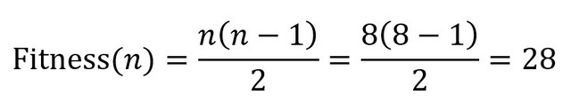
Mutation:
A mutation is an operator that causes a small change in a gene at random. The mutation must always follow two principles:
1.Production of new material genetics.
2.Take small steps.
Here we randomly select two points and move their genes together:
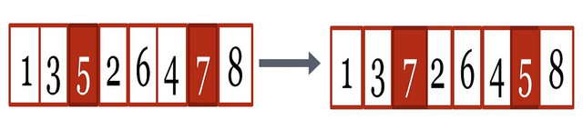
Crossover:
The Crossover operator combines two genes in the hope of recovery.
Here Crossover randomly selects a breakpoint and then combines two genes:
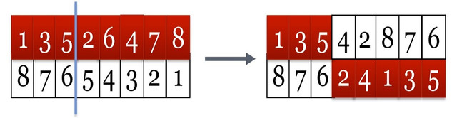
Selection:
The Selection operator selects the parents, randomly selecting 5 parents from the initial population, then selects 2 of the 5 parents with the best fitness. Then we apply the Mutation and Crossover operators to them.

3. i).Consider the following Bayesian network , where F=having the flu and C = Coughing

P(F) = 0.1 P(C/F) = 0.8,
F
C
(C/⌐F) = 0.3

- Write down the joint probability table Specified by the Bayesian Network (10)

- Determine the probabilities for the following Bayesian Network. (5)
C
F

- Which Bayesian network would you have specified using the rules learned in the class? (1)
- Are C and F independent in the Bayesian Network? (1)

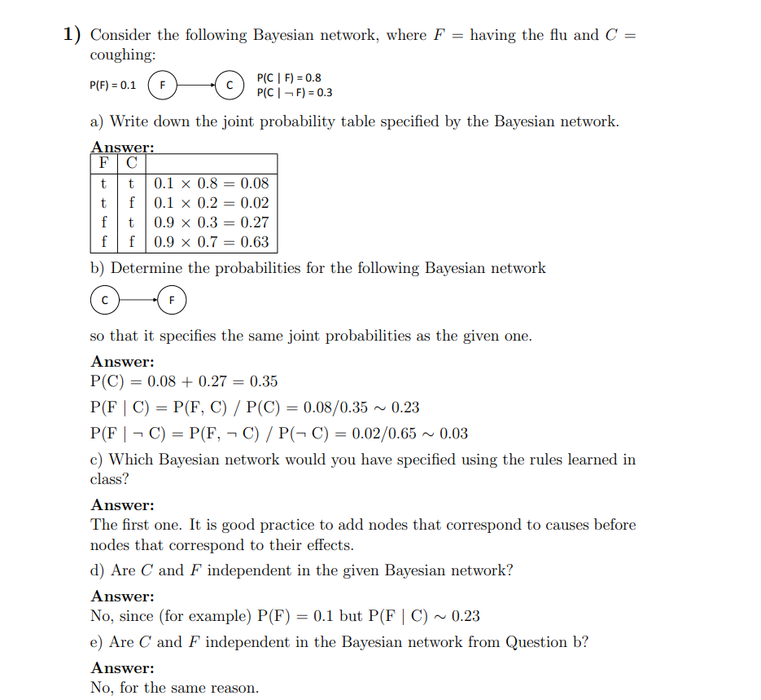
ii) By using NLP, I can detect spam e-mails in my inbox. Assume that the word ‘offer’ occurs in 80% of the spam messages in my account. Also, let’s assume ‘offer’ occurs in 10% of my desired e-mails. If 30% of the received e-mails are considered as a scam, and I will receive a new message which contains ‘offer’, what is the probability that it is spam?
Solution
- We need to find the total number of mails which contains ‘offer’ ;
24 +7 = 31 mail contain the word ‘offer’
2. Find the probability of spam if the mail contains ‘offer’ ;
In 31 mails 24 contains ‘offer’ means 77.4% = 0.774 (probability)
Solution with Bayes’ Equation:
A = Spam
B = Contains the word ‘offer’
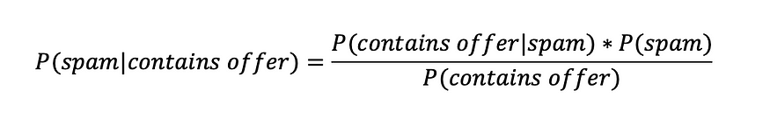
P(contains offer|spam) = 0.8 (given in the question)
P(spam) = 0.3 (given in the question)
Now we will find the probability of e-mail with the word ‘offer’. We can compute that by adding ‘offer’ in spam and desired e-mails. Such that;
P(contains offer) = 0.3*0.8 + 0.7*0.1 = 0.31
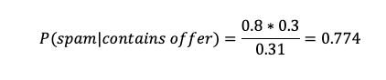
4. a. Write resolution algorithm and apply it to the Wumpus world problem to Convert the
B1,1 <-> (P1,2 V P2,1) into CNF.
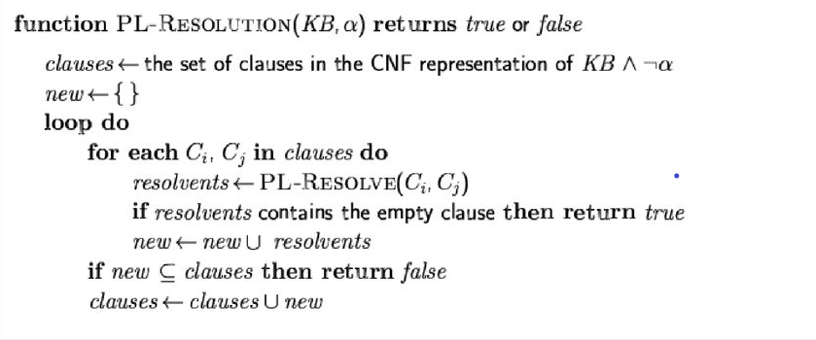
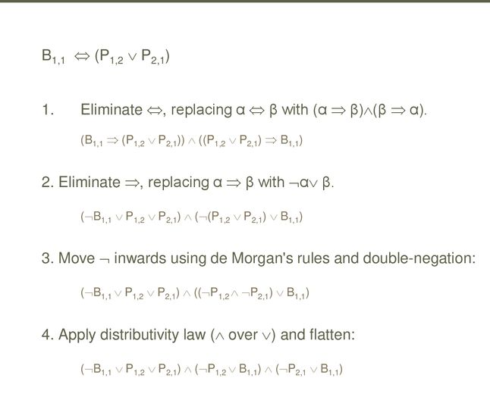
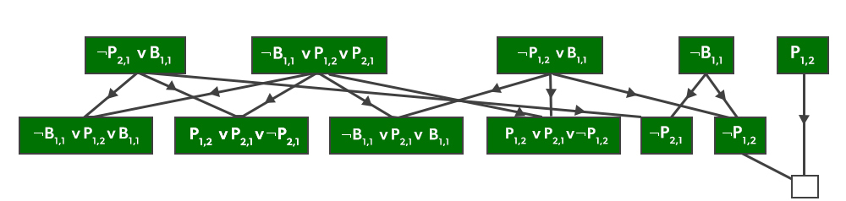
b. What is First order logic? Represent the following sentences in first-order logic, using a consistent vocabulary that you must define:
a) Some students took French in Spring 2001.
b) Every student who takes French passes it.
c) Only one student took Greek in Spring 2001.
d) The best score in Greek is always higher than the best score in French.
e) Everyone who buys a policy is smart.
f) No person buys an expensive policy.
g) There is an agent who sells policies only to those people who are not insured.
h) There is a barber who shaves all men in town who do not shave himself.

We define the following vocabulary:
took(x, y, z) : is true student x took subject y in semester z
score(x, y, z) : is true if student x obtains score z in subject y
passed(x, y) : is true if student x passed subject y
buys(x, p) : is true if person x buys policy p
isSmart(x) : is true if person x is smart
isExpensive(x) : is true if x is expensive
sells(x, y, p): is true if person x sells policy p to person y
isInsured(x): is true if person x is insured
isBarber(x): is true if x is a barber
shaves(x, y): is true if person x shaves person y
a) Some students took French in Spring 2001.
∃ x took(x, French, Spring2001)
b) Every student who takes French passes it.
∀ x, y took(x, French, y) ⇒ passed(x, French)
c) Only one student took Greek in Spring 2001.
∃ x, took(x, Greek, Spring2001) ∧
∀ (y, z took(y, Greek, Spring2001) ∧ took(z, Greek, Spring2001) ⇒ y = z)
d) The best score in Greek is always higher than the best score in French.
∃ x, s ∀ y, t score(x, Greek, s) ∧ score(y, French, t) ∧ s > t
e) Everyone who buys a policy is smart.
∀ x, p buys(x, p) ⇒ isSmart(x)
f) No person buys an expensive policy.
¬∃ x, p buys(x, p) ∧ isExpensive(p)
g) There is an agent who sells policies only to those people who are not insured.
∃ x ∀ y, p sells(x, y, p) ⇒ ¬isInsured(y)
h) There is a barber who shaves all men in town who do not shave himself.
∃ x ∀ y isBarber(x) ∧ ¬shaves(y, y) ⇔ shaves(x, y)

- Determine whether the expression is unifiable, if yes give a most general unifier P(h, g(x, h), f(y)), P(h, g(f(b), h), x)}
Here, Ψ₁ = P(h, g(x, h), f(y)), and Ψ₂ = P(h, g(f(b), h), x)
S₀ => {P(h, g(x, h), f(y)); P(h, g(f(b), h), x)}
SUBST θ= {f(b)/x}
S₁ => {P(h, g(f(b), h), f(y)); P(h, g(f(b), h), f(b))}
SUBST θ= {b/y}
S₁ => {P(h, g(f(b), h), f(b)); Q(h, g(f(b), h), f(b))}, Successfully Unified.
Unifier: [h/h, f(b)/x, b/y].

